Dharmendrasinhji Arts College, Rajkot
Dr. Yagnik Road, Ph./Fax No. (0281) – 2465632
Govt. Of Gujarat
(Affiliated with Saurashtra University)

7.1.3 Degradable and Non-degradable waste
There are different types of wastes disposed of in the college for which there is a proper system functioning. The following types of wastes are being disposed by our college:

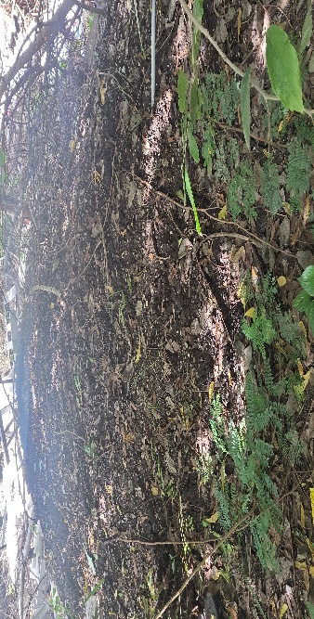
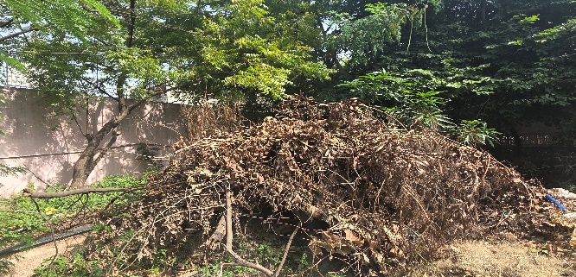
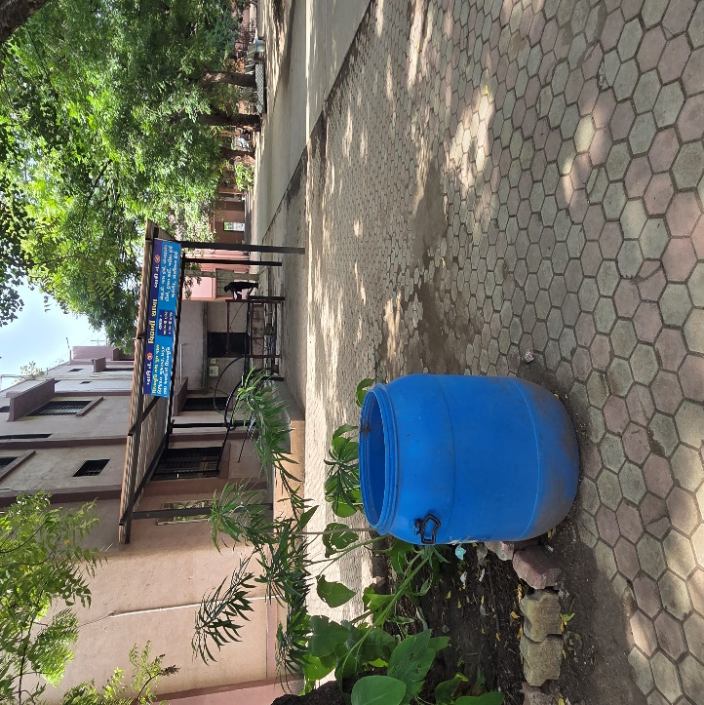
Solid waste management:

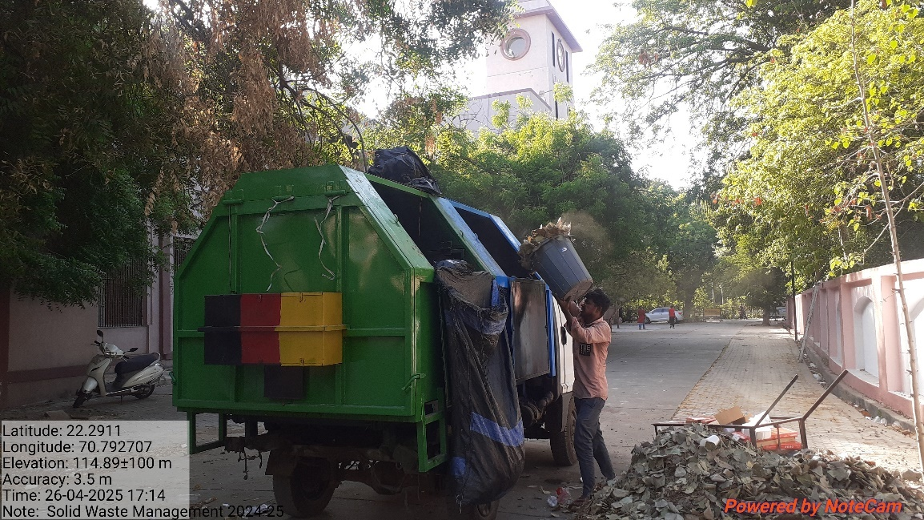

Liquid waste management (Underground Gutter):
